|  |  |  |  |  |  |
| --- | --- | --- | --- | --- | --- |
| Date | 23-Nov-22 | | | Tester Name | Mohammad Yusuf |
| Environment | Penfax - Test | | | Login used |  |
| Operating System | Windows | Version: | Update: | | |
| Software Used | Select Software | Version: | Update: | | |
| Select Software | Version: | Update: | | |
| Release version |  | | | | |
| Title |  | | | | |
| Test Type | Regression | | | | |
| Test Scenario | Initial Scenario was incorrect. Confirm with Rosie | | | | |
|  |  | | | | |
| Expected Results |  | | | | |
| Pass/Fail | Select | | | JIRA# | N/A |

Describe your steps with screenshots:

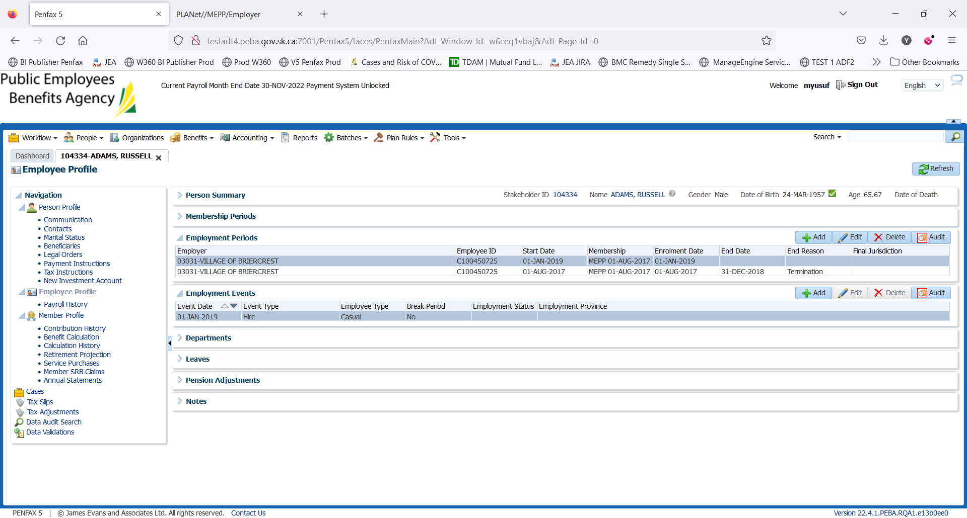

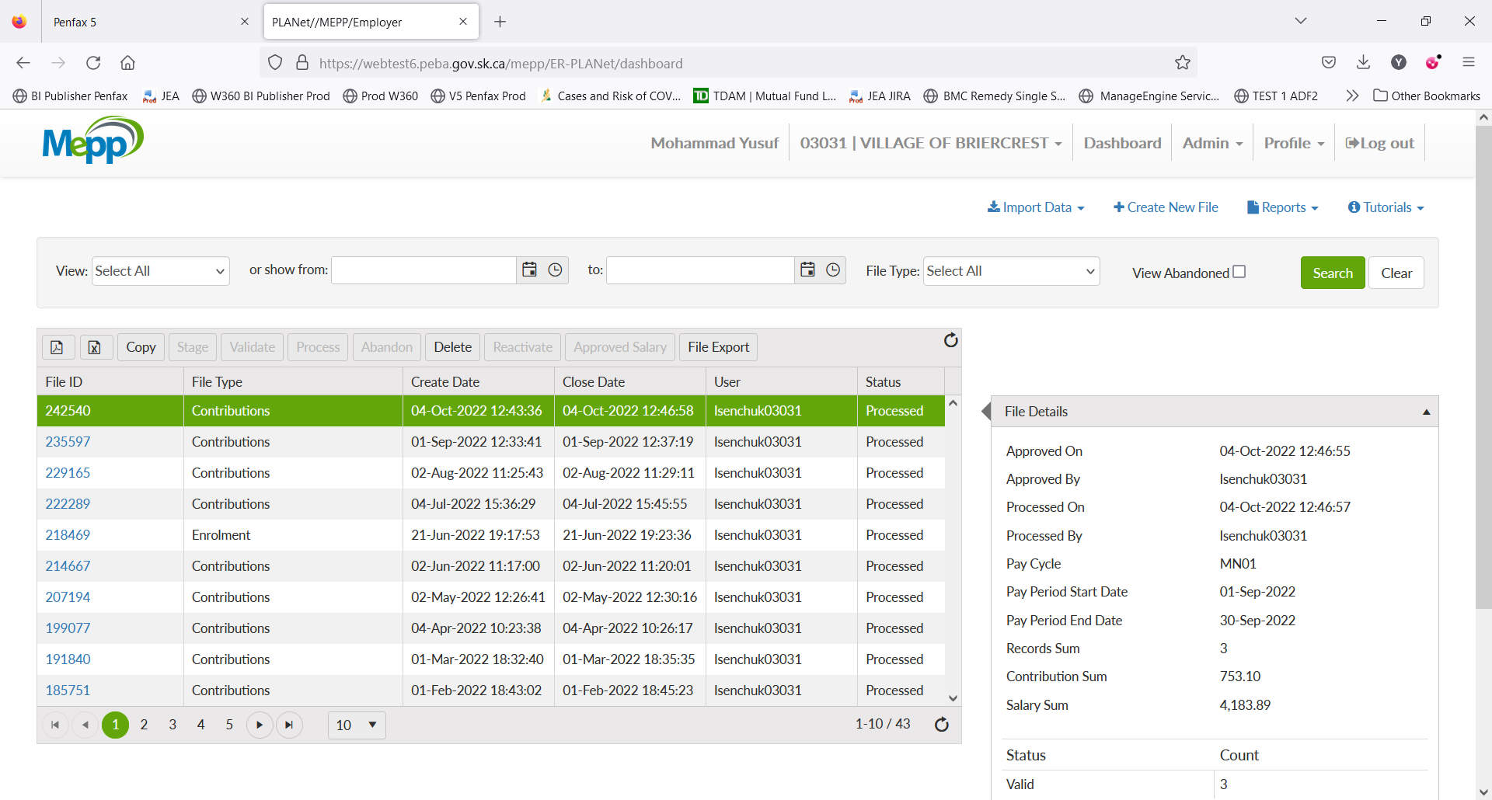

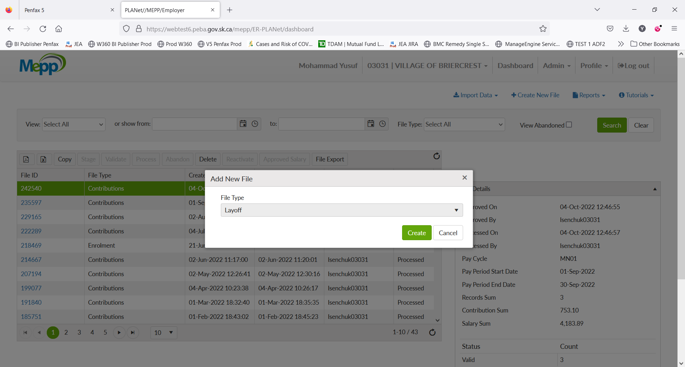

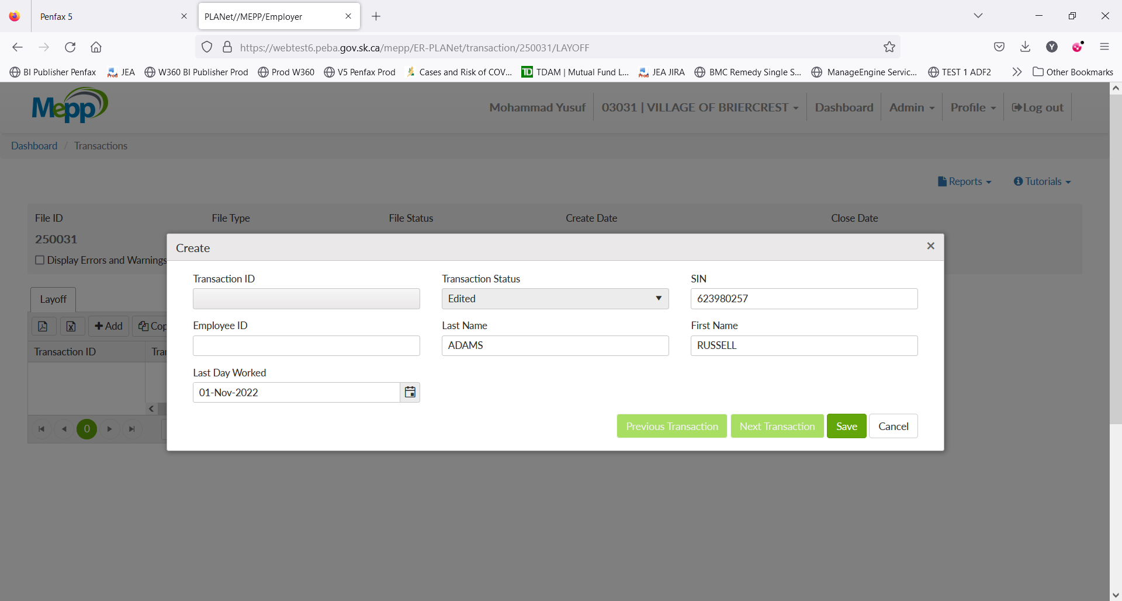

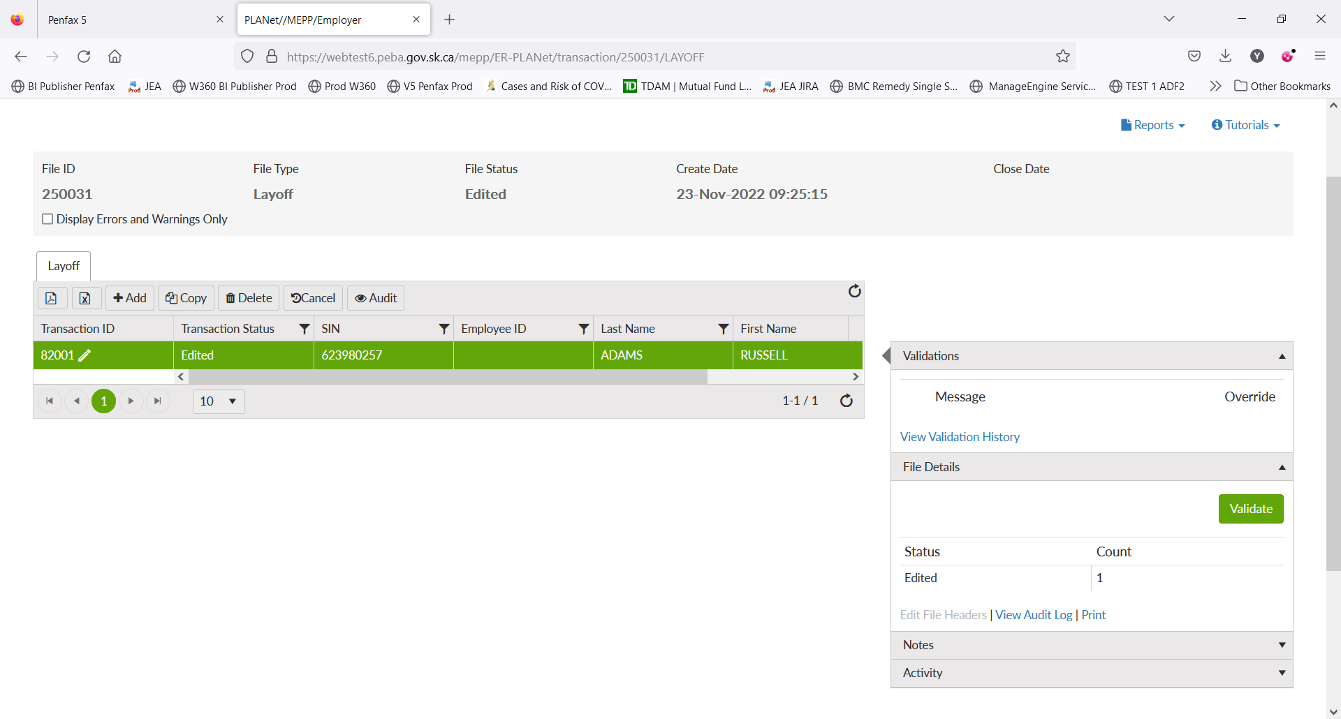

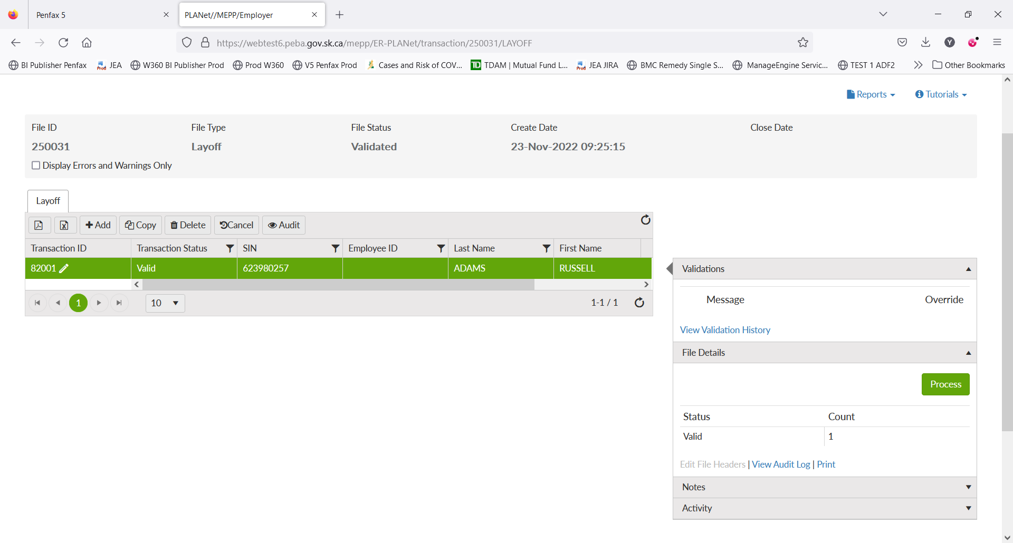

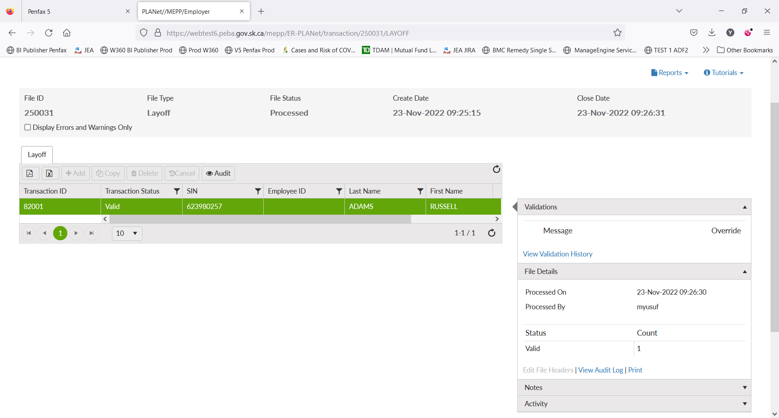

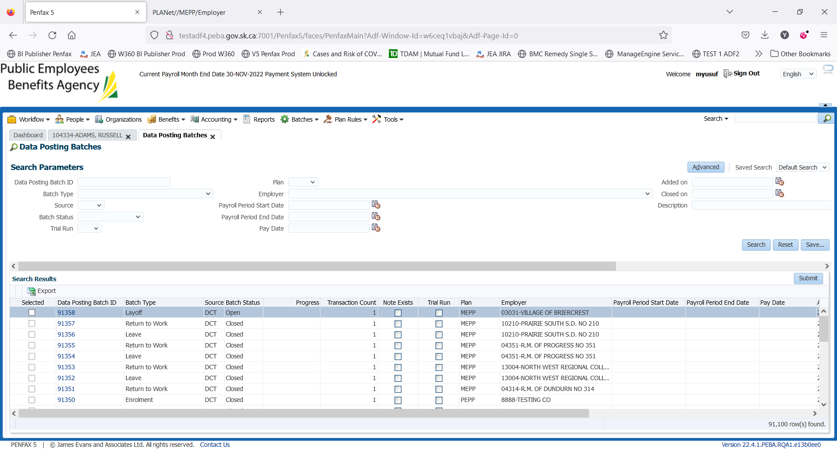

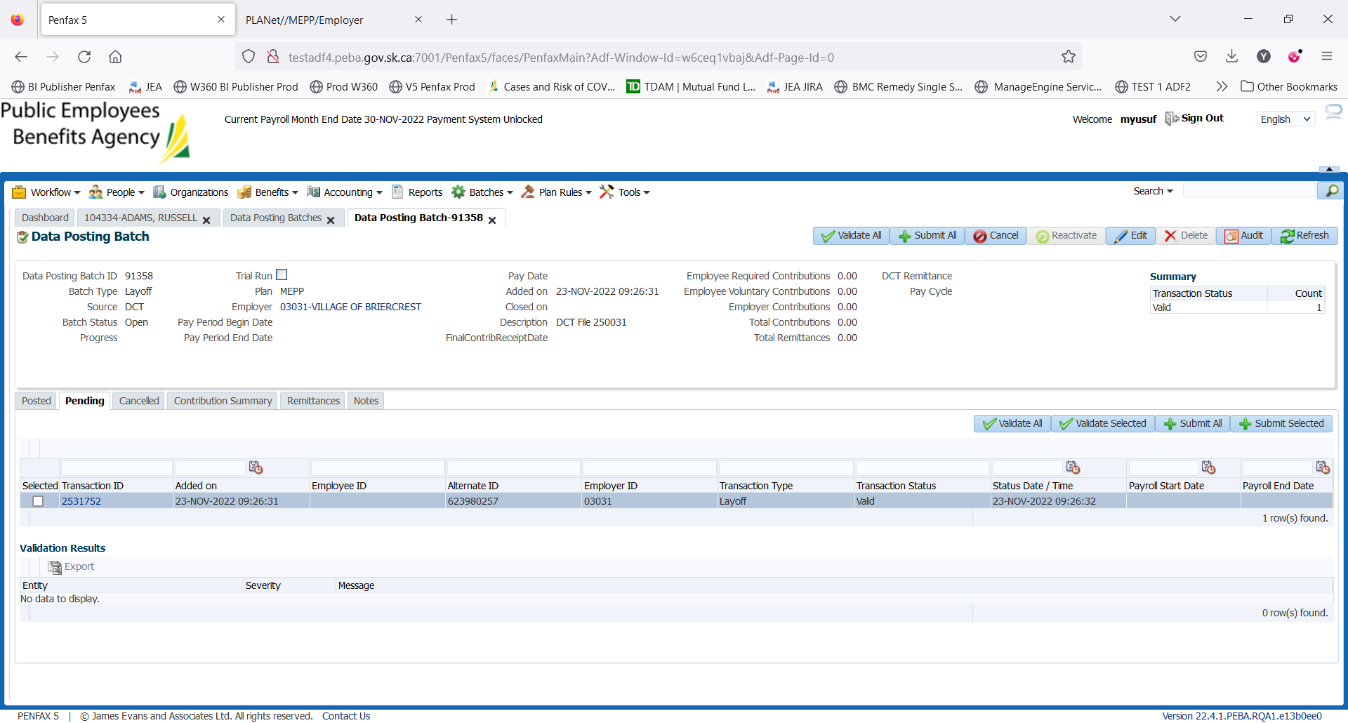

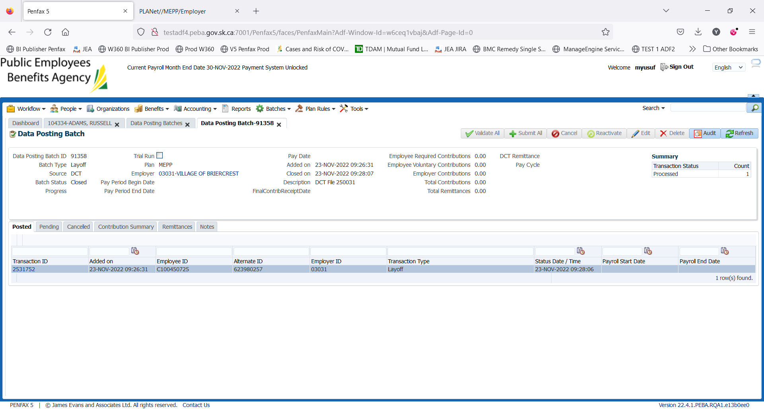

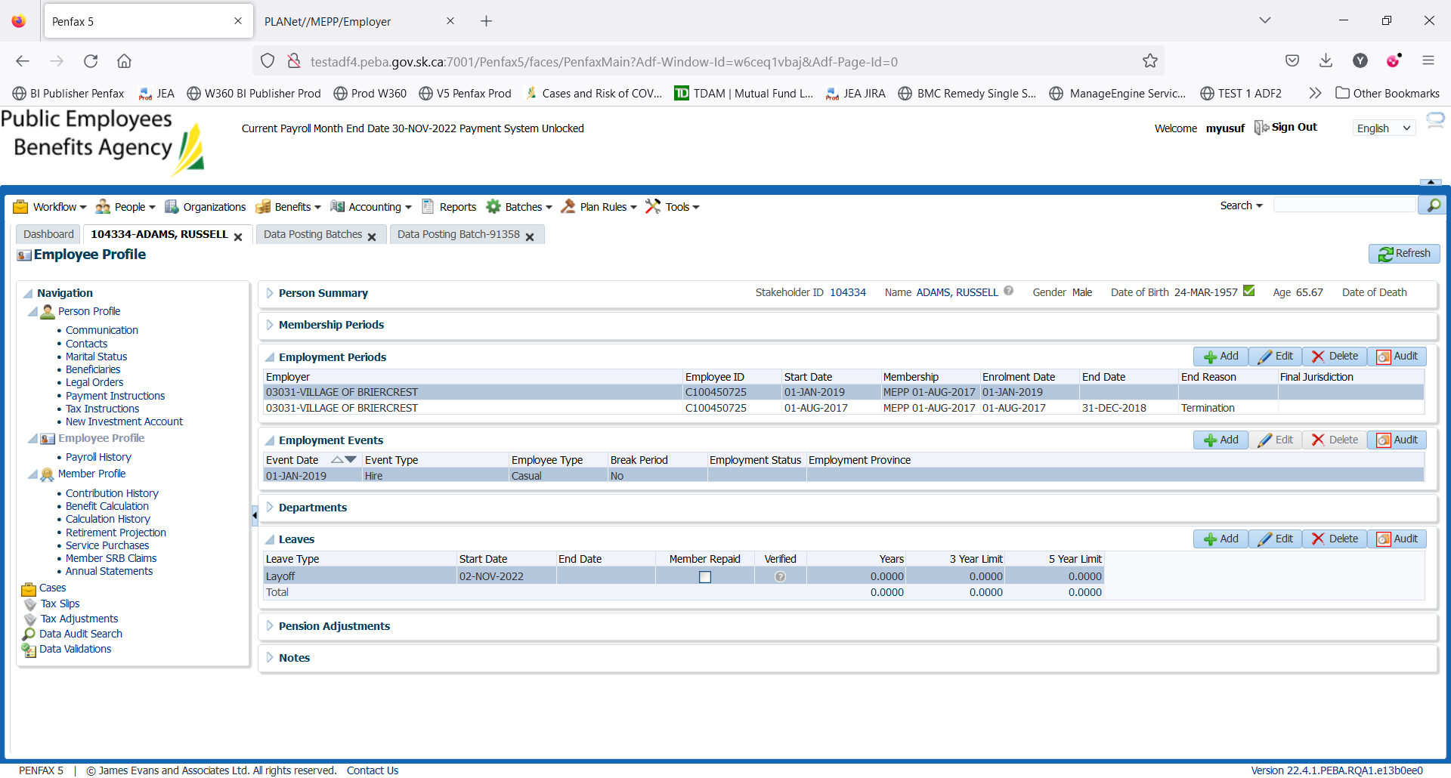

After placing the member on layoff. Now adding RTW.



